Exercises Biol-480 “Neuroscience” – Alzheimer’s disease

Solutions (10/11/2025)

General questions
- Where in the brain does Alzheimer’s disease (AD) start?
Entorhinal cortex
- Name 5 symptoms of Alzheimer’s disease (hint: the 5 A’s to diagnose AD).
Agnosia, amnesia, anomia, apraxia, and aphasia.
- What are the two main features that differentiate AD from non-AD age-related dementia?
AD: unknown cause and irreversible
Non-AD age-related dementia: Many causes, potentially reversible
- Name 3 pathophysiological hallmarks of AD.
Neuronal loss, neurofibrillary tangles, and amyloid plaques.
- What is “Braak and Braak” staging?
It refers to a method used to classify the degree of progression from mild cognitive impairment (MCI) to fully developed Alzheimer’s disease (AD).

Case study
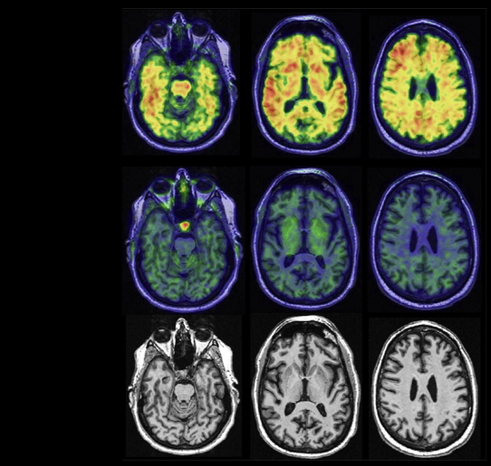
MRI
Tau PET
Amyloid PET
This figure shows PET and MRI scans of a cognitively unimpaired 67-year-old man.
- Do you observe any abnormalities in the amyloid PET images? Describe what you see and what it indicates.
There is widespread amyloid tracer uptake throughout the cortex, indicating amyloid deposition even though the individual is still cognitively unimpaired.
- Do you observe any abnormalities in the tau PET images? What does this suggest about tau pathology at this stage?
No abnormal tau signal is visible. This suggests tau pathology has not yet spread, consistent with early preclinical stages.
- Do you observe any visible abnormalities on the MRI images? What does this tell you about brain atrophy?
No significant cortical atrophy is seen. Brain structure appears largely preserved.
- Based on the PET and MRI findings, can you conclude that this patient has Alzheimer’s disease? What makes diagnosis difficult at this stage?
It is too early to diagnose Alzheimer’s disease. Although amyloid accumulation is present, tau pathology and atrophy are minimal, and the person remains cognitively normal. This case highlights the main diagnostic challenge: amyloid builds up years before symptoms, while tau spreading and neuronal loss, the main drivers of cognitive decline, occur later and are not correlated.

PET imaging of Tau Deposition
You will analyze images from a study of tau accumulation in the human brain (Schöll et al., 2016, Neuron). They used AV-1451 as the tau PET agent to examine retention patterns in cognitively normal older people (OA = older adults) compared to young controls (YA = young healthy adults) and patients with Alzheimer’s disease (AD).
β-amyloid is measured using PiB PET.
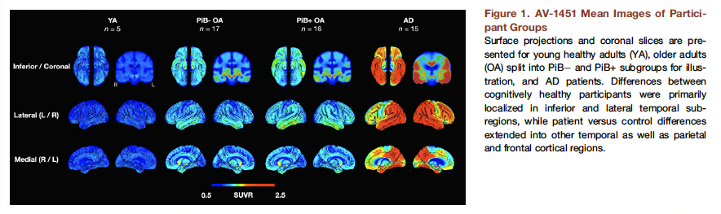
- Which brain region shows the earliest signs of tau tracer uptake in older adults compared to young adults? What do you conclude from the tau tracer uptake in this region, even in amyloid-negative older adults?
Medial temporal lobe regions. Tau deposition is part of normal aging.
- What do you observe when comparing amyloid-negative and amyloid-positive older adults? What does this suggest about the relationship between amyloid and tau?
We see an extension of tau deposits in amyloid-positive older adults. This suggests that amyloid pathology promotes tau spreading.
- What do you observe when you compare amyloid-positive older adults and AD patients? What can you conclude?
There is an extensive tracer uptake in AD patients across temporal, parietal, and frontal cortices. AD shows stronger and more widespread uptake, meaning a more advanced tauopathy associated with cognitive decline.
- When looking at all the images and the brain regions involved, what does tau accumulation predict here?
Tau accumulation here predicts memory decline.
- What are the advantages and limitations of PET imaging compared to post-mortem histology for studying tau pathology in aging and AD?
Advantages: In vivo, whole-brain imaging, disease-related changes measurements
Limitations: lower resolution, more expensive.

